File no: IRF20/3774
Report to the Northern Regional Planning Panel on an application for a site compatibility certificate under State Environmental Planning Policy (Housing for Seniors or People with a Disability) 2004
SITE: The Site Compatibility Certificate (SCC) application applies to part of Lot 1 DP 1128964, 31 Whitton Place, Mullaway (Figure 1). The proposed development is in the southwestern part of the lot (Figure 2). The lot is an irregular shaped and has three site frontages being Whitton Place (western frontage), Mullaway Drive (northern frontage) and Darkum Road (eastern frontage) (Attachment B).
The lot has a total area of 9.855ha. The site is bounded by residential properties varying in size, the Mullaway Primary School and Garby Nature Reserve to the north, caravan park and Mullaway village to the east and fragmented rural land to the south.
The site is zoned RU2 Rural Landscape under the Coffs Harbour Local Environment Plan (LEP) 2013. The site is currently improved by a dwelling house fronting Mullaway Drive and has three approvals over the site for:
- seniors living development (eastern part) which are currently under construction;
- 15 eco-tourism holiday cabins (construction certificate issued in 2003 – not yet constructed) within the development footprint of the proposed SCC; and
- restaurant fronting Whitton Street (western part).

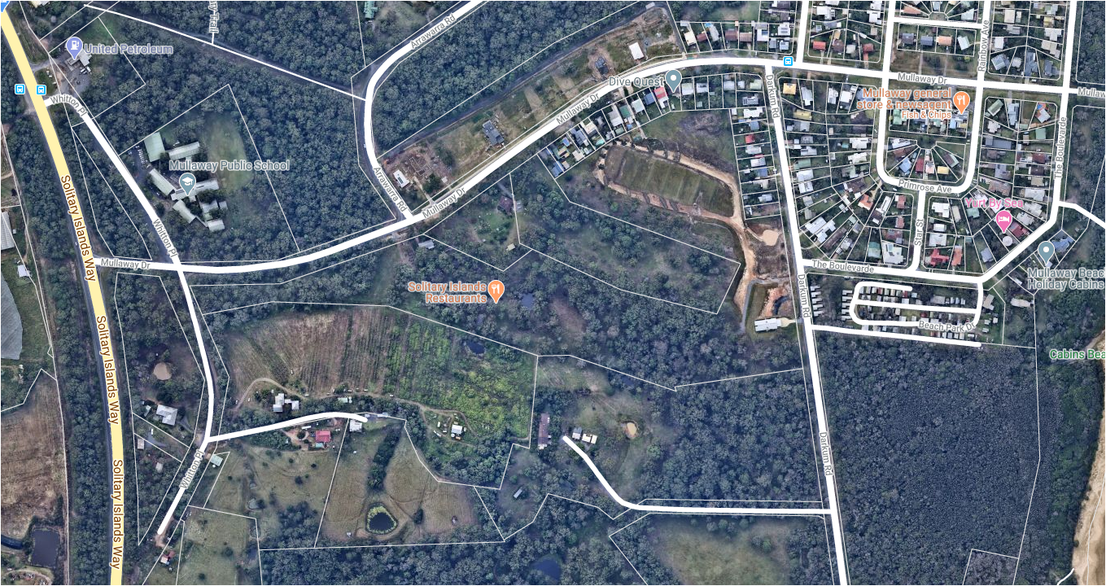
Subject site
Footprint of Eco-Tourism cabins
Development footprint
Approved SCC location
Existing house
Approved restaurant
Whitton Place
Subject site
Darkum Road
Mullaway Drive
Figure 1 – Subject site
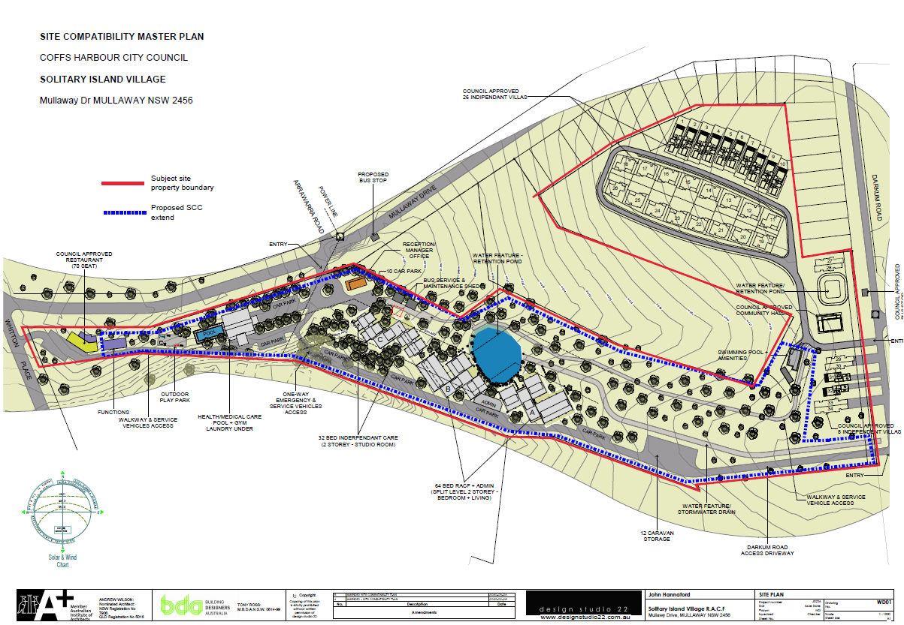
Proposed SCC footprint
Figure 2 – SCC site Masterplan and current SCC extent (Blue)
APPLICANT: GHD Pty Ltd on behalf of Solitary Islands Village Pty Ltd
PROPOSAL: The proposal is for a mixture of seniors living housing types and ancillary uses including:
- 64 bedroom residential aged care facility
- 32 bedroom independent self-care housing (studio villas) for people with a disability
- health and medical care facility
- pool, gym and laundry for onsite residential use
- onsite bus service
- associated carparking (unknown number of car parking spaces, delivery service spaces)
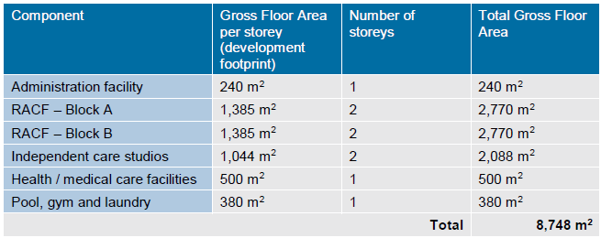
LGA: Coffs Harbour
PERMISSIBILITY STATEMENT
Site zoning
The site is zoned RU2 Rural Landscape under the Coffs Harbour LEP 2013.
Seniors housing is not permitted in the RU2 zone under the LEP or on land identified as environmentally sensitive under the State Environmental Planning Policy (Housing for Seniors or People with a Disability) 2004 (Seniors housing SEPP).
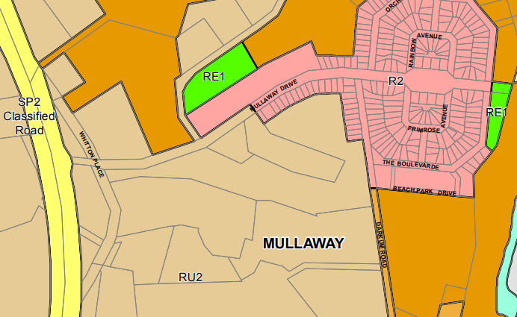
Subject site
E1
Figure 3– Site zoning
Seniors Housing SEPP
A SCC can be issued for land that is not zoned primarily for urban purposes provided it adjoins land zoned for urban purposes. Development on this site for seniors housing requires a SCC under Clause 24 of the Seniors Housing SEPP.
The provisions under Clause 4(1) of the SEPP provides that an SCC can be issued for the site as:
- dwelling houses are permissible in the RU2 Rural Landscape zone under the Coffs Harbour LEP 2013; and
- the site adjoins land zoned for an urban purpose, being the R2 Low Density Residential Zone.
The types of seniors housing proposed are ‘serviced self-contained dwellings’ and ‘residential care facility’ as defined in Clause 13 of the SEPP satisfying the requirements of Clause 17 of the SEPP for development that can occur on land adjoining land zoned primarily for urban purposes.
The site is not environmentally sensitive land as defined under schedule 1 of the SEPP despite a small area at the eastern entrance being mapped as within the coastal use area under the State Environmental Planning Policy (Coastal Management) 2018 (Figure 4).
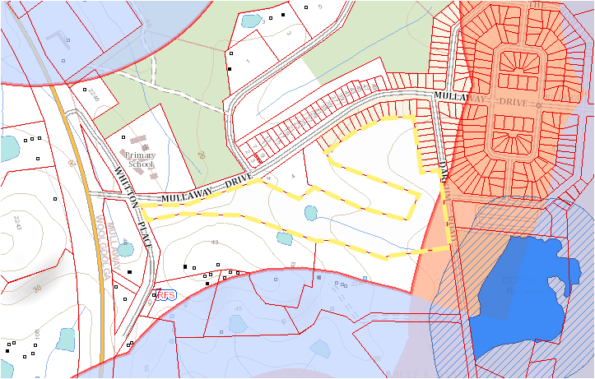
Development footprint
Coastal use area
Coastal Environment area
Proximity area Coastal Wetland
Coastal Wetland
Figure 4 - State Environmental Planning Policy (Coastal Management) 2018 map
PREVIOUSLY ISSUED SITE COMPATIBILITY CERTIFICATE ON THE LAND
Two SCC applications have previously been lodged for consideration on the subject land:
- on 23 September 2011, an SCC was issued for part of the subject lot (Attachment C) and the development is under construction. The SCC applied to the north-eastern portion of the site and was for a self-care housing development comprising of 34 single storey dwellings (two and three bedrooms), a village clubhouse, a maintenance shed and communal recreation facilities (Figure 5).
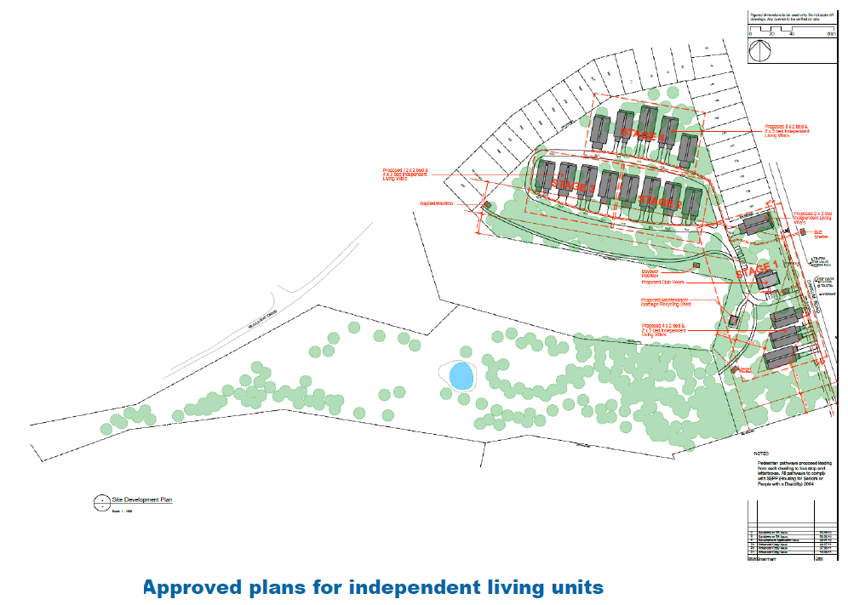
Figure 5 – SCC approval issued on 23 September 2011 (Approved plans for independent living units)
- on 27 August 2019, a SCC was refused for part of the subject lot (Attachment D). The refused SCC application applied to a similar part of the lot as the current SCC proposal. It was for a slightly more intense proposal consisting of a 64 bedroom residential aged care facility, 32 independent serviced self-care housing dwellings and 12 x 3 bedroom independent living villas and associated ancillary facilities (Figure 6).
The panel refused the application for the following reasons:
  - The proposed development is not compatible with the natural environment on the land, as it would require extensive clearing and modification of the existing vegetation, which includes mature trees and identified secondary koala habitat. The land has significant environmental value, being mapped as “high environmental value” land in the North Coast Regional Plan 2036. The Coffs Harbour Koala Plan of Management objective is to minimise further loss, fragmentation or isolation of secondary koala habitat and the creation of barriers to koala movement;
  - The land is adjoined by other mapped “high environmental value” land. The likely impact of the proposed loss of vegetation on koala usage of the land and other high environmental value land in the vicinity, particularly the adjoining Lot 1 DP 382303, was not addressed;
  - The potential impact of the proposal on Aboriginal heritage significance was not adequately addressed, noting the previous Aboriginal heritage study did not relate to this proposal;
  - The scale and character of the proposed development is potentially incompatible with the village character and existing community of Mullaway; and
  - The possible need for financial arrangements towards provision of Council services and infrastructure was not addressed and none was proposed.
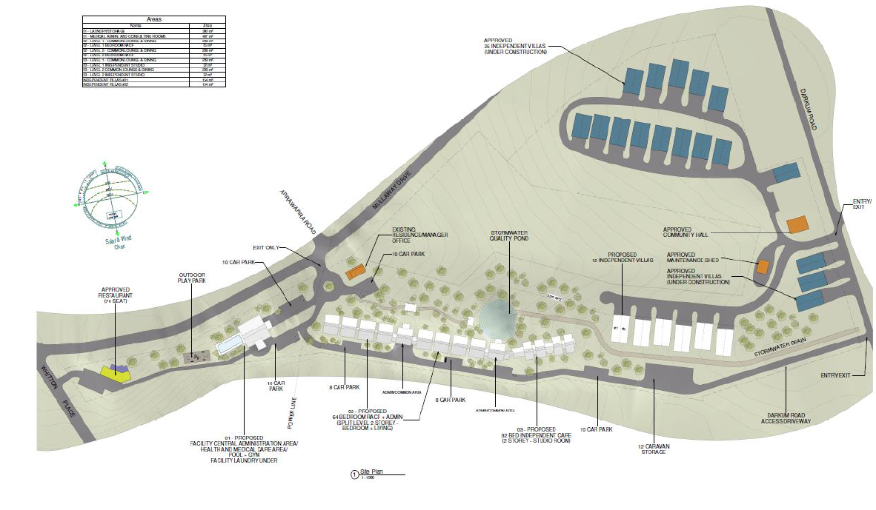
Refused SCC
Figure 6 – Proposed SCC application refused on 27 August 2019
The proponent has amended the current SCC to address the panel’s reasons for refusal as follows (Figure 7):
- consolidation of built form and removal of the 12 independent living villas to reduce the footprint and limit native vegetation removal to 3 hectares; and
- reduction in building bulk and scale and overall building footprint (804m² reduction in building footprint).
Proposed layout
Refused footprint
Consolidated building footprint
Removed 12 villas
Figure 7 – Building footprint comparison
PROXMITY OF SITE TO WHICH THERE IS A CURRENT SITE COMPATIBILITY CERTIFICATE, OR AN APPLICATION HAS BEEN MADE BUT NOT YET DETERMINED
The approved and refused SCCs are the only SCC applications that have been considered in within 1km of the site. A cumulative impact study is not required under clause 25(2)(C) as the SCC application is on the same land. The provisions of clauses 25(2A), 2(B) and 2(D) do not apply.
CLAUSES 24(2) AND 25(5)
The panel must not issue a certificate unless the panel:
  - has taken into account any written comments concerning the consistency of the proposed development with the criteria referred to in clause 25(5)(b) received from the general manager of the council within 21 days after the application for the certificate was made;
  - is of the opinion that:
    - the site of the proposed development is suitable for more intensive development; and
    - the proposed development for the purposes of seniors housing is compatible with the surrounding environment and surrounding land uses having regard to the criteria specified in clause 25(5)(b).
CLAUSE 25(2)(C)
A cumulative impact study has not been prepared as there are no current SCCs on land within a 1km radius of the site.
COUNCIL COMMENTS
Council was provided with a copy of the SCC application on the 27 July 2020 and additional information on the 21 August 2020. Council provided comments regarding the SCC on the 26 August 2020 (Attachment E). The Council submission noted that the comments “identify and address technical matters only”.
Council has provided the following comments regarding the application:
- parts of the subject site are mapped as secondary koala habitat and the Coffs Harbour Koala Plan of Management 1999 (KPoM) applies and the proposal / development application must satisfactorily address the KPoM regardless of what offsetting arrangements are available under the Biodiversity Conservation Act 2016 for the clearing of native vegetation. It is recommended that the developer be asked to more comprehensively address how the provisions of the KPoM will be met;
- a cultural heritage assessment has been prepared for the site and has not been reviewed. When submitted, it would refer the matter to the Biodiversity Conservation Division (former Office of Environment and Heritage) for its input at the development application stage;
- the proposed development would require a section 100B bushfire safety authority under the Rural Fires Act 1997 and, as such, any development application for seniors housing would be referred to the NSW Rural Fire Service as either ‘integrated development’ (if nominated by the applicant) or for its advice under the Environmental Planning and Assessment Act 1979;
- concerns are raised with the proposed road access point onto Mullaway Drive, particularly in relation to the distance from the Mullaway Drive/Arrawarra Road intersection and sight distances;
- the development will generate the need for water and sewerage services being extended to the site. The site is not covered by Council’s Water Supply and Sewerage Servicing Strategy and the proposed development is unplanned and may require changes to Council’s infrastructure. In addition, the site is not covered by Council’s developer contributions plans;
- the proposed development will surround Lot 1 DP 382303 to the north, and it may be a source of land use conflict if it is approved; and
- the bulk and scale of the proposal development is considered to be inconsistent and out of character with that of the surrounding locality, which largely accommodates low density residential land uses.
The matters raised by Council are considered below in the body of this report.
SUITABILITY FOR MORE INTENSIVE DEVELOPMENT
The panel must not issue a certificate unless the panel is of the opinion that the site of the proposed development is suitable for more intensive development (clause 24(2)(a)).
- The site of the proposed development is suitable for more intensive development (clause 24(2)(a))
The subject site is located adjacent to the village of Mullaway. The surrounding area is characterised by low-density housing to the north and west of the site, areas of natural vegetation and rural/rural residential housing to the south.
The subject site is not located within the urban growth area in the North Coast Regional Plan 2036 (Figure 8). The site is also not identified within the coastal village area of Mullaway/Arrawarra (Figure 9) or identified as an investigation area for growth in the Coffs Harbour Draft Local Growth Management Strategy (Figure 10).
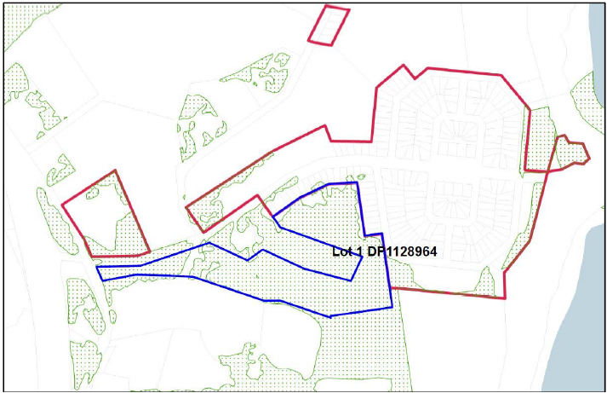
Potential High Environmental Value
Urban Growth Boundary
Subject site
Figure 8 – Urban growth boundary and Potential High Environmental Values
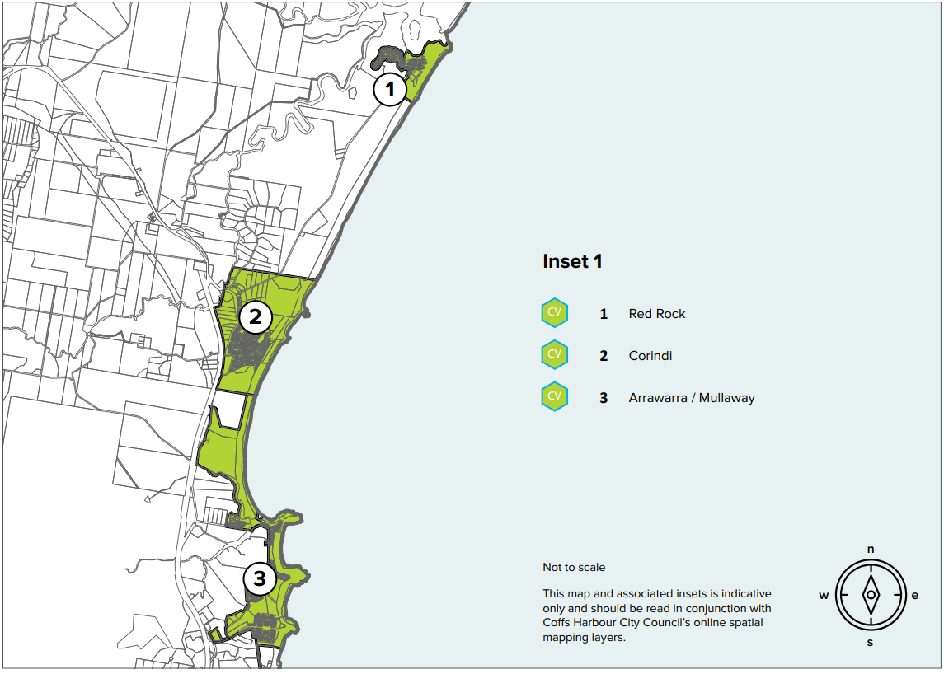
Subject site
Figure 9 - Coffs Harbour LGMS 2040 – Place making diagram Coastal Village map
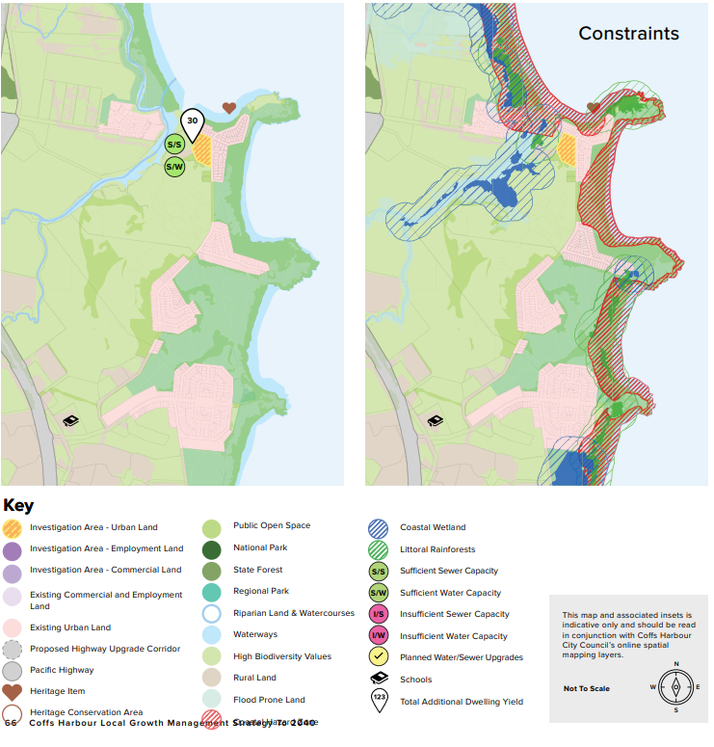
Subject site
Figure 10 – Coffs Harbour LGMS 2040 – Growth area Arrawarra
As discussed further in this report, it is considered that the current SCC application does not provide sufficient detail or evidence to confirm that the site is suitable for the proposed development regarding the clearing of native vegetation, koala habitat impacts, Aboriginal cultural heritage impacts, traffic and intersection design impacts and expansion of infrastructure provisions to the site. While some constraints could be satisfactorily addressed through appropriate design responses at the development application stage should an SCC be issued, it is considered that any development of the site for more intensive purposes would be premature until sufficient information is provided as part of the SCC application as detailed above.
COMPATIBILITY WITH THE SURROUNDING ENVIRONMENT AND LAND USES
The panel must not issue a certificate unless the panel is of the opinion that the proposed development for the purposes of seniors housing is compatible with the surrounding environment and surrounding land uses having regard to the following criteria (clause 25(5)(b)) and clause 24(2)(b)):
- The natural environment (including known significant environmental values, resources or hazards) and the existing and approved uses of land in the vicinity of the proposed development (clause 25(5)(b)(i))
The site contains fragmented open forest vegetation communities and is identified as bushfire prone land. The proposal is not identified as being impacted by flooding, subject to potential contamination or important farmland. The proposal aims to consolidate the built form to minimise vegetation clearing and reduce impacts from hazards.
Vegetation
The subject site has been modified from its natural state by ongoing rural management but still retains significant quantities of native vegetation. The applicant’s SCC report notes that the majority of the proposed development footprint is within an area of the site which has been heavily disturbed from past agricultural activities and on land that has been the subject of past development approvals.
The applicant’s SCC report outlines that the site supports two similar open forest vegetation communities (Eucalyptus pilularis (Blackbutt) Open Forest and Eucalyptus pilularis – E. resinifera (Blackbutt – Red Mahogany) Open Forest) and one swamp open forest community (Melaleuca quinquenervia – Eucalyptus tereticornis – Lophostemon suaveolens (Paperbark – Forest Red Gum – Swamp Box) Open Forest).
The subject site is not mapped on the Terrestrial Biodiversity Map under the Coffs Harbour LEP (Figure 11) or the NSW Government Biodiversity Values Map and Thresholds Tool (Figure 12). However, the land is mapped as having ‘potential high environmental value’ in the North Coast Regional Plan 2036 (Figure 8).
An area of approximately 3ha of vegetation will be cleared to facilitate the development and likely impact on PCT690 Blackbutt - Tallowwood dry grassy open forest of the central parts NSW North Coast Bioregion (NR119) or PCT692 Blackbutt – Tallowwood moist ferny open forest of the coastal ranges of the NSW North Coast Bioregion (NR120) (the exact number of trees and vegetated area has not yet been specified).
The previously approved SCC on the site relied on a biobanking offset site at the southern end of Darkum Road, approximately 500m to the south of the site and it is outlined that there is existing capacity at this site should further offsetting be required. However, since this previous approval the BioBanking Scheme has been replaced by the Biodiversity Offsets Scheme (BOS) under the Biodiversity Conservation Act 2016 (BC Act) and the Biodiversity Assessment Methodology (BAM). The BAM includes a new credit calculator which has different credit impact and generation rates than the previous system. The applicant’s SCC report notes that there would likely be a shortfall of credits on the existing biobanking offset site required to offset the proposed development. The ability to seek any shortfall in further offsets required by the proposal were noted in the applicant’s SCC report, however a preferred site was not detailed.
If the SCC was to be issued, the preparation of a biodiversity assessment report in accordance with the biodiversity assessment method would be necessary at the development application stage. The Biodiversity Conservation Division (BCD) would be consulted on the proposed offsetting arrangements at that time.
The extent, quality and ongoing management of the site vegetation has not been detailed in the SCC application. Furthermore, a detailed ecological assessment or tree survey has not been carried out or provided to support the current SCC application and its statement that the proposed development has been consolidated and refined to areas of least environment impact. It is also noted that additional clearing of vegetation is likely to be required due to the site’s bushfire prone nature. Due to the lack of supporting information, it is not considered possible to determine the extent, impact or appropriateness of the proposed vegetation removal associated with the proposal.
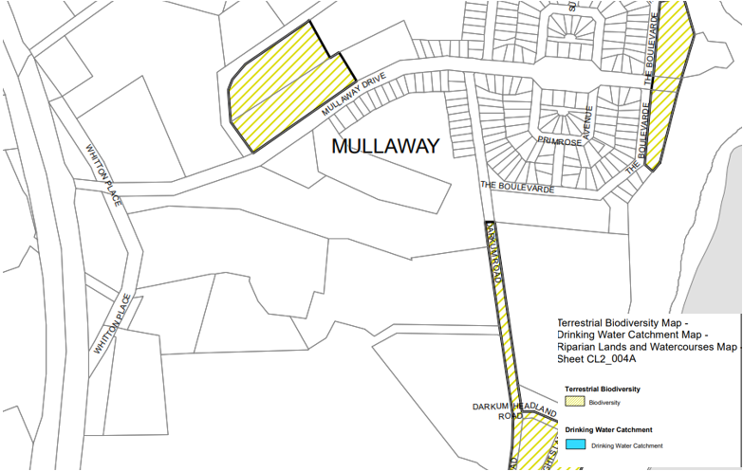
Subject site
Figure 11 – Terrestrial Biodiversity Map Under the Coffs Harbour LEP
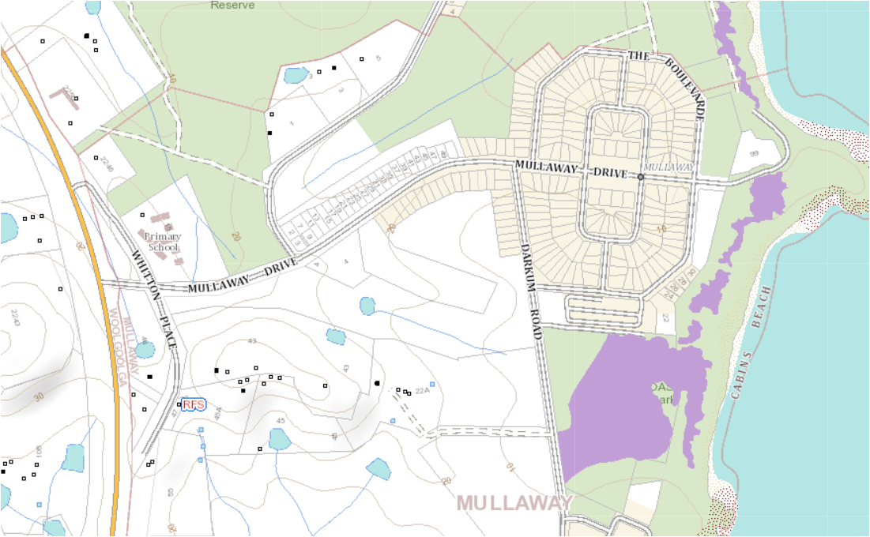
Subject site
Figure 12 - Biodiversity values map
Koala Habitat
The applicant’s SCC reports outlines that the Coffs Harbour LEP 2013 and Coffs Harbour City Koala Plan of Management, identifies that the site contains ‘secondary koala habitat’. The objective for this habitat type within the management plan is to minimise further loss, fragmentation or isolation of secondary koala habitat and the creation of barriers to koala movement, and where appropriate, to encourage restoration of koala habitat. The plan stipulates that a consent authority shall not grant consent to the carrying out of development on areas identified as secondary koala habitat that will remove the following koala feed tree species:
- tallowwood;
- swamp mahogany;
- flooded gum, except when part of a forest plantation;
- forest red gum; and
- small-fruited grey gum unless the development will not significantly destroy, damage or compromise the values of the land as koala habitat.
The proponent has indicated that the removal of koala habitat has been minimised in the current SCC via a consolidated footprint and modified design to maintain a koala corridor through the site (Figure 13) and that any potential impacts will be addressed and considered through the biodiversity offset scheme.
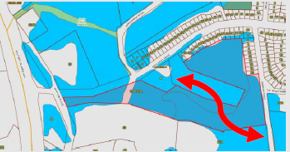
Figure 13 – Potential koala corridor (Source: GHD SCC Report)
The SCC application is not supported by any detailed documents or reports to demonstrate that the development footprint, vegetation removal or proposed corridor will reduce impacts to koala habitat or demonstrate compliance with the objectives of the KPoM. Council has raised concerns over this issue. Due to the lack of supporting information, it is unknown whether the corridor width and location is appropriate, or if the overall impact on koalas and their habitat can be adequately mitigated.
Bushfire
The land is mapped as being bushfire prone (Figure 14). The proposal is a ‘Special Fire Protection Purpose’ defined under Planning for Bushfire Protection 2019 as “Developments where the vulnerable nature of the occupants means that a lower radiant heat threshold needs to be accommodated for in order to allow for the evacuation of occupants and emergency services”.
The applicant’s SCC report includes additional information and assessment methodologies of how bushfire impacts are proposed to be managed onsite. It is noted that clearing of vegetation is required to achieve the RFS APZ standards under the Rural Fires Act 1979. It also noted that “a meeting was held with NSW Rural Fire Service’s (RFS) in Coffs Harbour in May 2020 to discuss the above assessment. The RFS clarified what their expectations are in regard to aged care developments and the level of assessment required and did not offer any objections to the proposal”.
If the SCC is approved, additional reporting and assessment of bushfire to demonstrate compliance with the objectives of Planning for Bushfire Protection 2019 will be required at DA stage. It is considered that the matter of bushfire can be adequately considered and addressed at the development application stage, however as noted above, this may have significant implications on the removal of native vegetation.
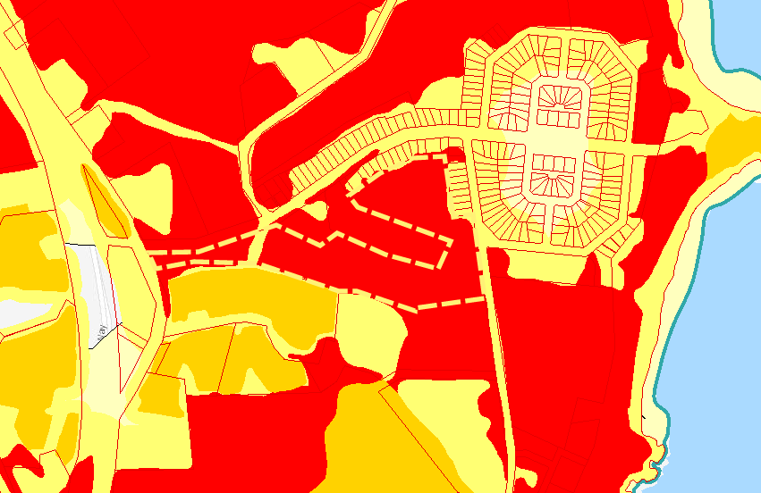
Category 1
Category 2
100m Buffer
Subject site
Figure 14 – Bushfire map
Cultural heritage
Artefacts of Indigenous heritage have been identified on and near the subject site. A cultural heritage due diligence assessment was prepared in 2012 for the entire lot to support the development application for the previously approved seniors living development. That report addressed the entire lot and concluded that the seniors housing development could proceed with caution due to the expectation that the development is unlikely to impact on Aboriginal cultural heritage on the site.
BCD (Former OEH) was contacted for input into the consideration of the previous SCC application and advised that part of the site is within a known Aboriginal cultural heritage landscape and there is a registered AHIMS (Aboriginal Heritage Information Management System) artefact site within approximately 35m of the subject site. The AHIMS registered site is at the western end of the subject site on the northern side of Mullaway Drive.
Despite previous reporting and supporting documents for development applications detailing presence of Aboriginal cultural heritage items onsite, a detailed cultural heritage assessment was not undertaken or provided to support the current SCC application. Without a detailed Aboriginal cultural heritage assessment, it is not considered that the potential impacts or the appropriateness of the proposal in regard to this issue can be adequately determined.
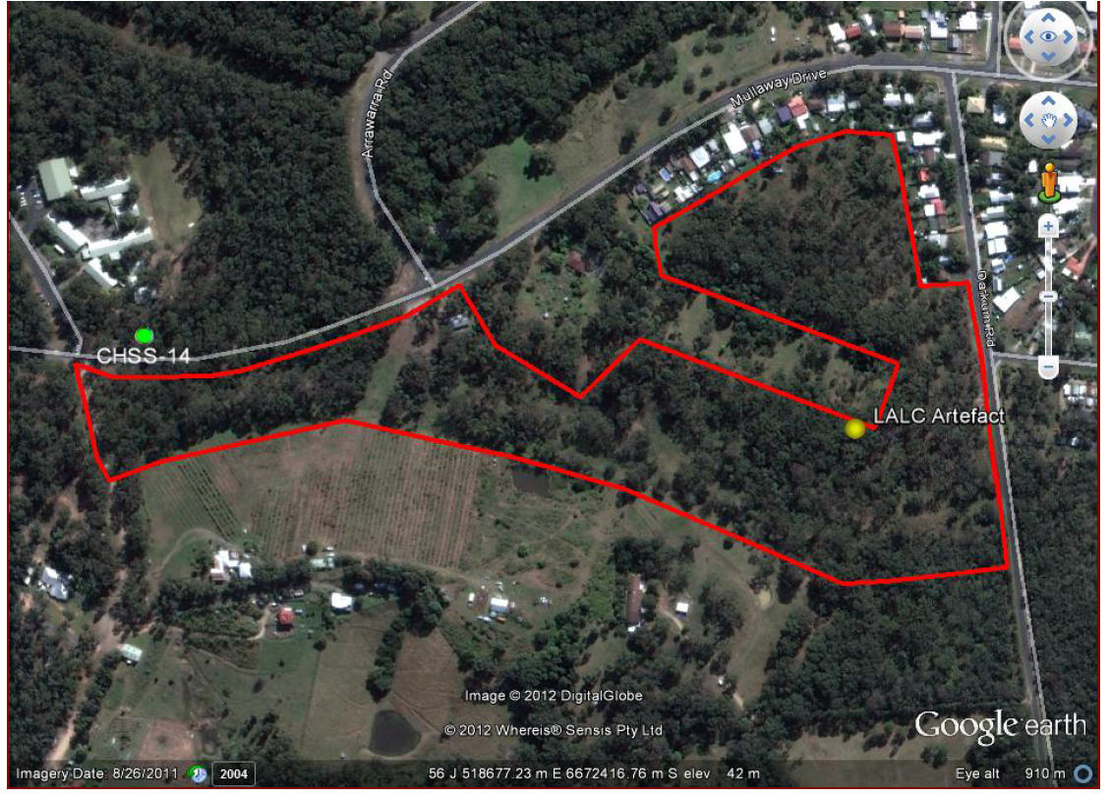
Subject site
Figure 15 - Cultural heritage due diligence assessment 2012 sites in or near footprint
Acid sulfate soils
The site is mapped as Class 5 acid sulfate soils under the Coffs Harbour LEP 2013 (Figure 16). The LEP contains suitable measures that can be considered and addressed at the development application stage to ensure development and earthworks carried out within land identified as containing or potentially containing acid sulfate soils are appropriately managed.
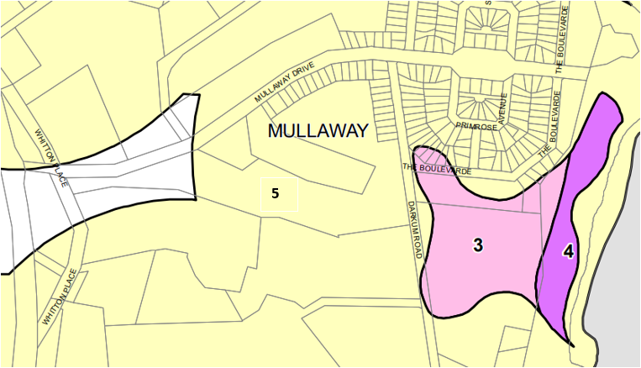
Acid Sulfate Soils Class
Class 3
Class 4
Class 5
Subject site
Figure 16 – Acid Sulfate Soils Map

Offsite land use conflicts
The site is located within close proximity to existing low density residential development, rural uses and rural residential development. Due to the existing uses already approved on the site (seniors living, holiday cabins and a restaurant), the proposed seniors housing development is not anticipated to result in a significant increase in conflict with the existing uses in the area.
- The impact that the proposed development is likely to have on the uses that, in the opinion of the panel, are likely to be the future uses of that land (clause 25(5)(b)(ii))
The applicant’s SCC report outlines that there are “no land use hazards in the immediate area (such as poultry operations, heavy or potential hazardous or offensive industries), which could be considered as potential land use conflicts”.
The proposal is unlikely to adversely conflict with the various approvals and likely future uses onsite including an eco-tourist accommodation, a restaurant and the seniors living development. The site is therefore able to be considered for further seniors living development upon consideration of potential impacts and constraints at the development application stage.
- The services and infrastructure that are or will be available to meet the demands arising from the proposed development (particularly, retail, community, medical and transport services having regard to the location and access requirements set out in clause 26) and any proposed financial arrangements for infrastructure provision (clause 25(5)(b)(iii))
The subject site comprises a total area of approximately 9.855ha and is located adjacent to the village of Mullaway which is 30 kms north of Coffs Harbour. The immediate and surrounding areas of Woolgoolga and Coffs Harbour and additional infrastructure and servicing provisions onsite contains a variety of community, commercial, retail, health and medical services to meet the needs and demands of the proposal in accordance with clause 26 of the Seniors Housing SEPP.
Transport services
A regular bus service is available in Mullaway that is part of a network that services the surrounding area and provides access to major shops, banking services and retail/commercial uses in Woolgoolga (5km), Coffs Harbour (30km) and Grafton (55km). The bus services pass the site as part of the Woolgoolga regional service (Grafton to Coffs Harbour) route no. 372 (Figure 17), with the closest bus stop being the Mullaway General Store, approximately 450m from Darkum Road frontage of the site. Additional services offered by Forest Bus Service include an on-demand service called ‘Woopi Connect’ which connects Mullaway to Woolgoolga.
Additional supporting services and bus stop infrastructure noted in the applicants SCC report to support this development:
- the “Solitary Island Village will provide a private bus service to supplement transport service for regulate resident excursions, special community events and services to meet the residents needs”.
- “Council has approved the development of a bus stop along Darkum Road and a further bus stop is proposed on Mullaway Drive adjacent to this proposal”.
There are currently no footpaths located on the southern side of Mullaway Drive, western side of Darkum Road or Whitton Place to access the development site. If the SCC is to be approved, other matters such as pathway and pathway grades can be appropriately assessed as part of the development application. It is considered that these matters comply with the requirements of clause 26(2)(c) of the Seniors Housing SEPP.
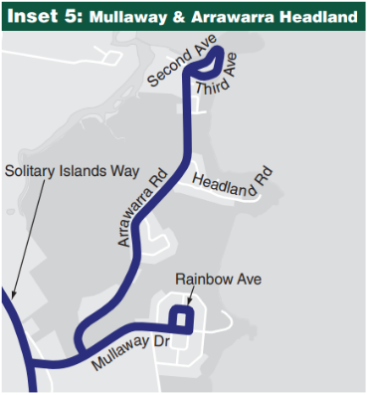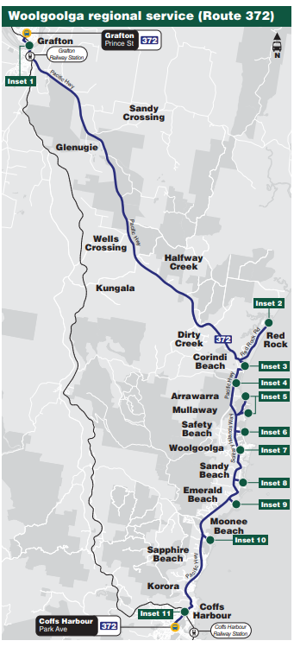
Subject site
Figure 17 – Public transport route
Road network and traffic generation
The proposed SCC master plan illustrates the internal road/driveway network and the access points to Darkum Road, Mullaway Drive and Whitton Place. The report however only describes proposed site access on Darkum Road and sight lines at the intersection of Mullaway Drive/Darkum Road and Mullaway Drive and Solitary Islands Way.
The site access onto Mullaway Drive (just west of Arrawarra Road) or additional traffic onto Whitton Place has not been detailed. Potential impacts such as sight lines, intersection design and traffic generation are required to be considered. Council has also raised concerns in relation to the absence of a detailed traffic report. The potential impacts on local street networks and the safety and efficiency of the road network therefore cannot be determined under the present application.
Retail, community and medical services
The applicant’s SCC report confirms that the proposed development includes the following onsite services; meals; cleaning services; personal services; and nursing services. The proposal also includes communal facilities such as a swimming pool, gym, caravan storage, and playground. It is noted however there are no concept plans or supporting details regarding the services.
Additional offsite services include:
- the Mullaway General Store (450m) for basic shopping and post office needs
- Woolgoolga (5km) and Coffs Harbour (30km) for other retail facilities and a variety of community services such as banking, sporting, entertainment and professional services.
Offsite medical services are available in Woolgoolga, Coffs Harbour and Grafton for dental, medical, paramedical, optometry, pathology and physiotherapy). Coffs Harbour has a public (Coffs Harbour Base Hospital) and private (Baringa Private Hospital) hospital which service the North Coast region for referrals, general medicine, surgical and emergency services.
Infrastructure provisions
The site is adjacent to an urban area with existing sewer, water, electricity and telecommunication services however the subject site is currently not covered by Council’s water supply and sewerage servicing strategy, and any new infrastructure for the proposed development would be unplanned and may require alterations to existing infrastructure; or covered by Council’s developer contributions plans. Therefore, it is likely that new connections/upgrades will be required to service demands compatible with future development.
A preliminary assessment was undertaken by the applicant to determine if the existing infrastructure network has capacity for the development loads on the water and sewer infrastructure network. The assessment concluded:
- Sewer network: Council’s existing sewerage infrastructure has adequate capacity and does not required alterations or changes to take the load of the proposed development.
- Water infrastructure: It was determined that the existing water infrastructure network does not have adequate pipe sizing to meet standards if the proposed development is serviced from the Darkum Road connection point with the current network infrastructure. It is concluded however with upgrades to the network and/or moving the connection point to infrastructure with greater capacity, the network would be able to provide adequate capacity to meet the demand of the proposed development.
Despite the preliminary assessment concluding that the network has existing capacity, it also noted that augmentations to the water infrastructure network will be required. The proposal does not include a concept financial agreement or proposal for infrastructure provisions. Council has also noted that the development is unplanned and therefore may require changes to Council’s infrastructure.
- In the case of applications in relation to land that is zoned open space or special uses—the impact that the proposed development is likely to have on the provision of land for open space and special uses in the vicinity of the development (clause 25(5)(b)(iv))
This clause is not applicable as the subject site is not zoned for open space or special use.
- Without limiting any other criteria, the impact that the bulk, scale, built form and character of the proposed development is likely to have on the existing uses, approved uses and future uses of land in the vicinity of the development (clause 25(5)(b)(v))
The existing and potential uses to the north and east of the site consist of low-density residential accommodation, the low scale caravan park to the east and rural residential properties to the west and south. The Coffs Harbour LEP 2013 height of building provisions for the entire area is a maximum building height of 8.5m (Figure 18). The approved SCC over the eastern portion of the site is also less than 8.5m and generally one storey in nature.
The SCC application includes concept plans of the proposed residential accommodation illustrating the proposed building bulk, scale and form (Figures 19 – 21). Council has raised concerns that the bulk and scale is inconsistent and out of character with the locality.
The buildings will range from one to two storey in height with a maximum building height of 8.5m. The concept plans illustrate the buildings ‘stepping’ with the topography of the site to reduce the built form and scale of the development within the natural contours of the land and reduce any visual impacts of the development from Mullaway Drive and Darkum Road. The proposal also includes significant areas of open space and landscaping at ground level. It is noted however that the detailed plans of the ancillary buildings/structures containing the medical/health care service, laundry, pool and gym facilities have not been provided as part of the SCC application.
The proposal consolidates the built form onsite along the southern boundary which reduces the footprint of development. The proposed vegetation to be retained along the northern boundary of the site will provide a vegetation buffer to the existing rural residential land and dwelling to the north.
It is considered that the proposed development is not inconsistent with the height requirements of the Coffs Harbour LEP 2013 or the existing approved uses and future uses of land in the vicinity of the development. If the proposal was to proceed, further detailed design and assessment of the built form outcomes could be assessed at the DA stage.
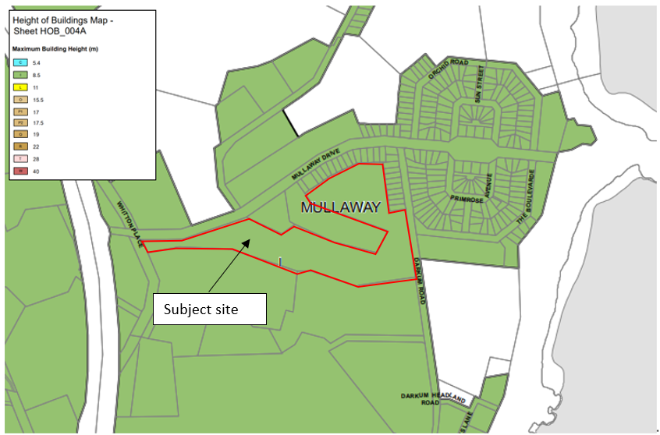
Figure 18: Height of building map

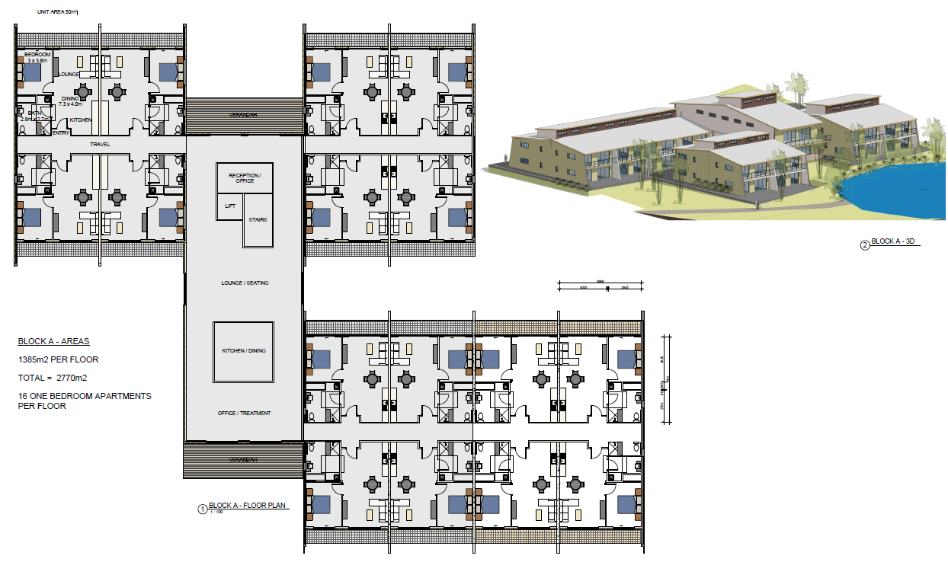
Figure 19: Built form and scale Block A
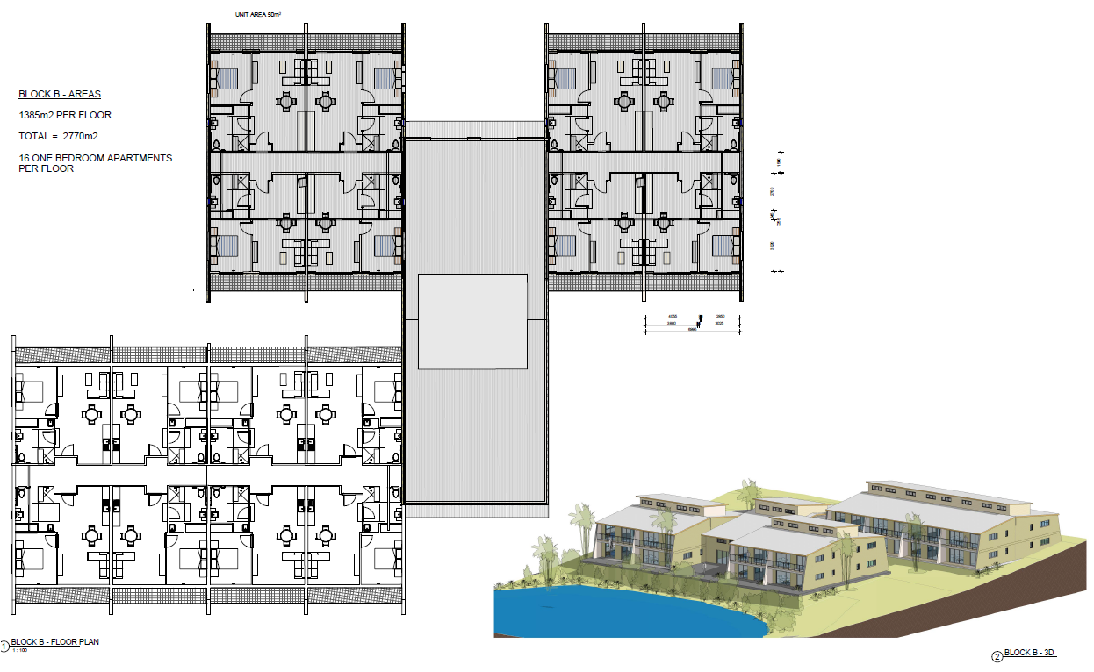
Figure 20: Built form and scale Block B
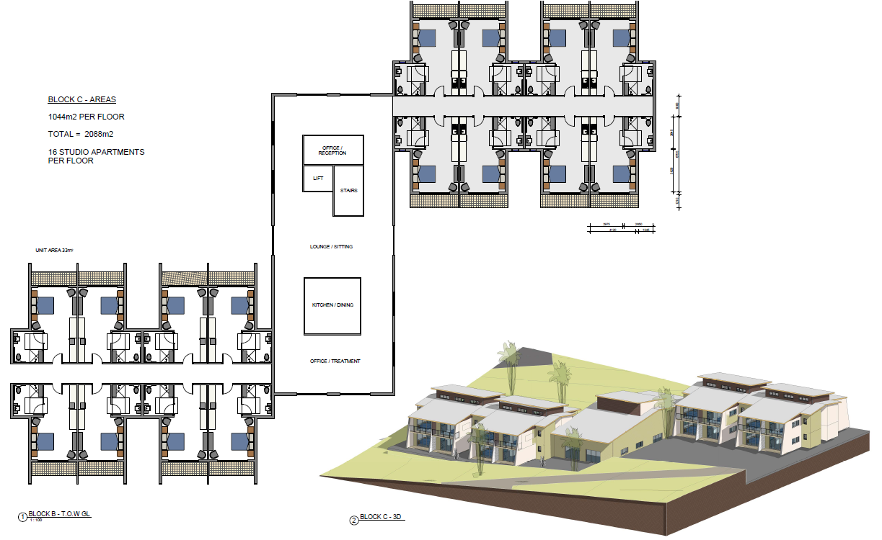
Figure 21: Built form and scale Block C

- If the development may involve the clearing of native vegetation that is subject to the requirements of section 12 of the Native Vegetation Act 2003—the impact that the proposed development is likely to have on the conservation and management of native vegetation (clause 25(5)(b)(vi))
The Native Vegetation Act 2003 has been repealed and does not apply to the proposal. Native vegetation will be cleared for the proposed development and to ensure compliance with bushfire legislation. Although the site has been modified through agricultural processes and previous clearing activities, the site is identified as having secondary koala habitat. This clearing would trigger the need for consideration under the Coffs Harbour KPoM and the Biodiversity Conservation Act 2016 for the potential environmental impacts.
The SCC application indicates that offsetting the loss of native vegetation can be undertaken, however as discussed above, in the absence of sufficient information, the impact of the proposed development on the ongoing conservation and management of native vegetation is unable to be determined.
- The impacts identified in any cumulative impact study provided in connection with the application for the certificate (clause 25(5)(b)(vii))
A cumulative impact study is not required under the Seniors Housing SEPP as there are no current or undetermined SCCs on land within a 1km radius of the subject site.
RECOMMENDATION
The site is considered unsuitable for more intensive development for the purposes of seniors living having regard to the criteria set out in clause 25(5)(b) of the Seniors Housing SEPP because the SCC application contains insufficient information supporting the suitability of the site regarding:
- native vegetation clearing,
- koala habitat impacts,
- Aboriginal cultural heritage,
- traffic impacts; and
- infrastructure provisions.

ATTACHMENTS
Attachment A – Applicants SCC application report
Attachment B – Site map
Attachment C – Previous approved SCC
Attachment D – Previous refused SCC
Attachment E – Council comments
Attachment F – Site inspection report

Contact officer: Rebecca Carpenter
Planning Officer, Northern Region
Contact: 6643 6421

